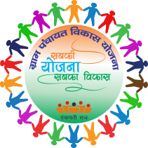
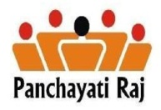
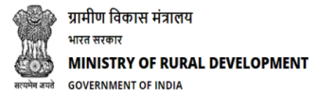
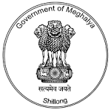

MY VILLAGE MY PLAN
VDP-GPDP
Programme Schedule for Block level Environment Generation Campaign VDP –GPDP
Time | Topic |  | Resource Person
9.30 am-10.00 am | Registration |  | Gram Sevika
10.00am-10.20am | Introduction to the programme by BDO |  | BDO
10.20am-11.00am | Orientation of VDP-GPDP |  | State Resource Group(SRG) Team
11.00am-11.15 am | Tea Break
11.15am-1.00pm | Presentation by the Line Department (5 minutes each )  - Social Welfare Department  - Family welfare and Health Department  - Education Department  - Agriculture and Horticulture Department  - AH&Vety Department  - P.H.E.D Department  - PWD(PMGSY) Department t  - Commerce and Industries Department t  - Forest & Environment Department  - Fishery Department  - Meghalaya Electricity Power Corporation Limited. | - Irrigation and Water Resource Department.  - Soil Conservation Department  - Sports and Art & Culture department  - Tourism Department  - Sericulture & Weaving Department  - BADO  - Co-operation Department  - Employment and Craftsmen Department.  - Housing Department  - Food ,Civil Supplies and Consumer Affairs  - Revenue and Disaster management Department  - MSRLS-NRLM  24.SRES-MGNREGS
1.00pm-1.10pm | Instruction to the VEC/Village Council Chairman and Secretary |  | BDO/SRG Team
1.10pm-1.45pm | Lunch Break
1.45pm-2.15pm | Preparation of Calendar for VDP-GPDP plan at village level : Discussion and presentation |  | SRG Team/Support team from Block offices.
2.15pm-2.30pm | Presentation of Block Resource Envelope |  | SRG Team
2.30-pm-3.00pm | 1.Discussion on Development in the villages 5 years ago (2012-2017)  2.Discussion on development in the villages in the current year(2017-18)  3. Discussion on Development in the villages in the next 5 years (2018-2023) |  | SRG Team (Minutes of the discussion shall be recorded by the SRG team)

Sd/-
Block Development Officer

