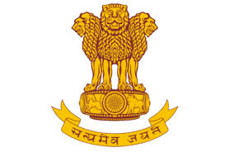
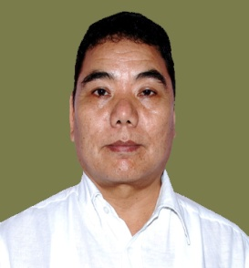
ARUNACHAL PRADESH
Phone: (O): 0360-2212558 Fax : 0360-2215786

Alo Libang
Minister (PR, RD & Health & FW)

AN APPEAL

The Ministry of Panchayati Raj, Govt. of India is launching “People’s Plan Campaign” from 2nd October to 31st December 2018 for preparation of Comprehensive Gram Panchayat Development Plan (GPDP) for the year 2019 - 2020 across the Country. The plan so prepared will contain proposals of all 18 Departments related to 29 subjects as devolved to the Panchayati Raj Institutions (PRIs). In order to finalize the Comprehensive Gram Panchayat Development Plans, there will be as many as 3 (three) “Gram Sabhas” in all Gram Panchayats across the State starting from 2nd October 2018.

Therefore, I appeal all the adult members of all villages to participate in the respective Gram Sabhas for preparing inclusive Gram Panchayat Development Plan which addresses the basic needs of the concerned Gram Panchayats.

(Alo Libang)

