Gram Panchayat Development Plan (GPDP)
2nd October to 31st December 2018
Sabki Yojana Sabka Vikas
URL: gpdp.nic.in
About GPDP:
The GPDP campaign will be an intensive and structured exercise for planning at Gram Sabha level through convergence between Panchayati Raj Institutions (PRIs) and concerned Line Departments of the State. Gram Panchayats have been mandated for the preparation of Gram Panchayat Development Plan (GPDP) for economic development and social justice. The GPDP planning process has to be comprehensive and based on participatory process which involves full convergence with Schemes of all related Central Ministries / Line Departments related to 29 subjects listed in the Eleventh Schedule of the Constitution. The People’s Plan Campaign will be rolled out as ‘Sabki Yojana Sabka Vikas’ from 2ndOctober to 31stDecember, 2018. During the campaign, structured Gram Sabha meetings will be held for preparing Gram Panchayat Development Plan (GPDP) for the next financial year
Types Of users in GPDP:
Users will be created at the different hierarchy by the upper next level. First time, user need to change the password by using forgot password functionality. The user needs to click on the forgot password link and enter the user login id (Mobile number). 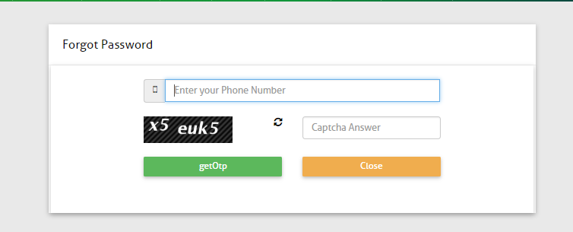

An OTP would be sent to user mobile and mail box which will be activated for next 30 minutes. Post entering the OTP, it will redirect user to changes the password for GPDP portal

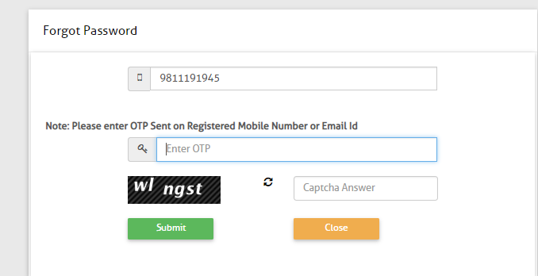
After putting the received OTP, user will be redirected on the password reset screen as mentioned below.
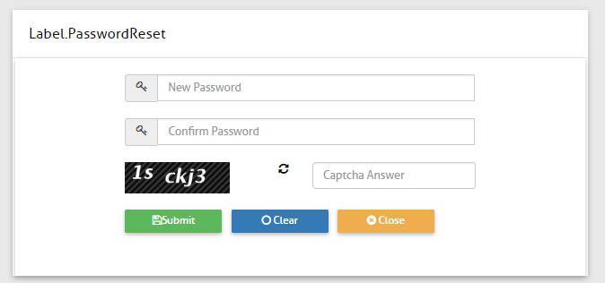

Level of Users
- State User (Nodal Officers): NIC officials will create the state nodal officers. Full Name, Designation, Mobile number and email id will be captured for the State User (Nodal officer). Mobile number should be unique as mobile number is the login id of user. State Nodal Officers username and password will be generated at the central level.
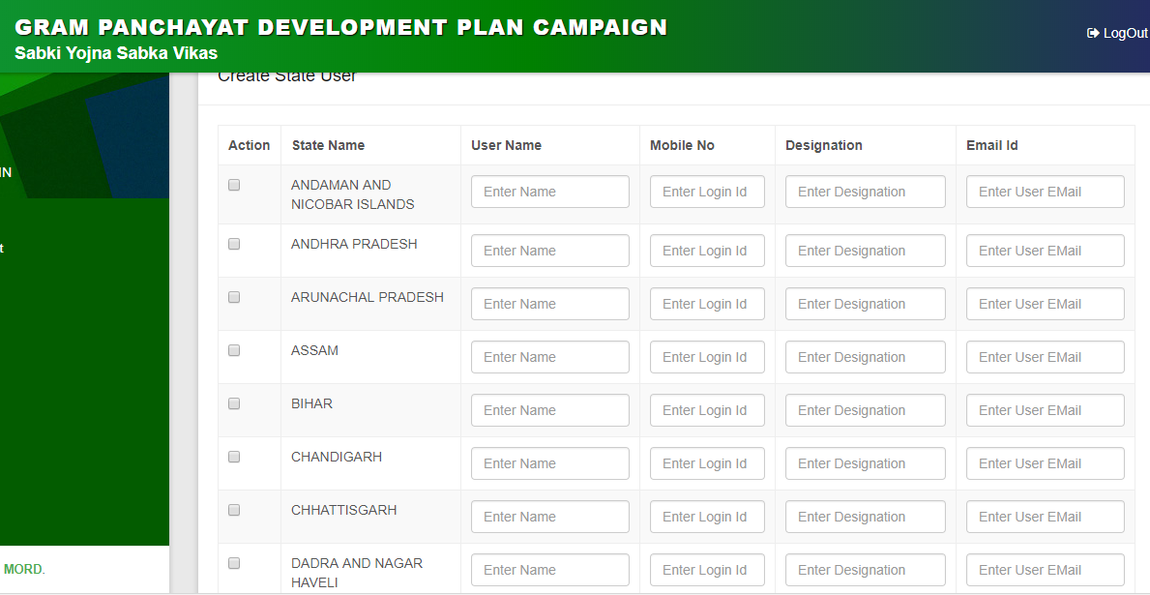

- District Panchayat (DP) level users: State user can create the further user of DPRO (District Panchayati Raj Officer) and DM (District Magistrate) for the respective district. DP level user can also create the Facilitators and front line users. Designation, Mobile number, email id and full name will be captured of the registered user. Single user of DPRO and DM at a single district is allowed.
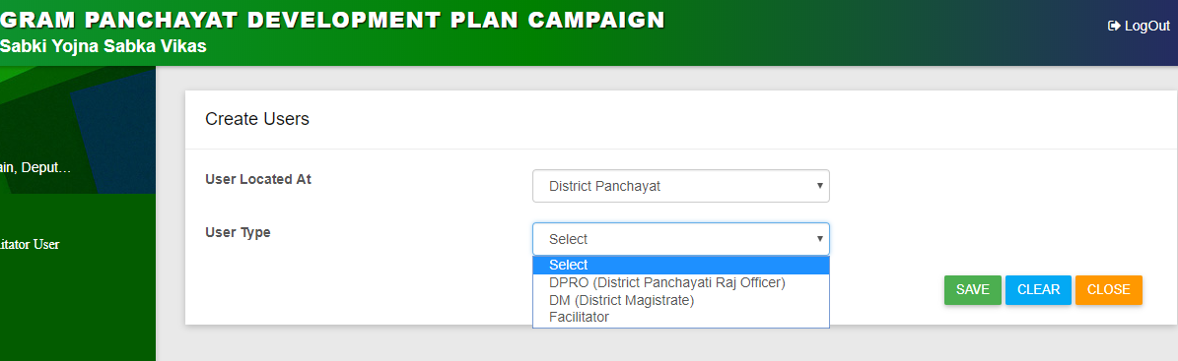

- Intermediate Panchayat level users: District level users can create the BPRO (Block Panchayati Raj Officer) and BDO (Block Development Officer) for the respective block in a district. BP level user can also create the facilitators and frontline worker users. Designation, Mobile number, email id and full name will be captured of the registered user. Single user of BPRO and BDO at a single block is allowed.
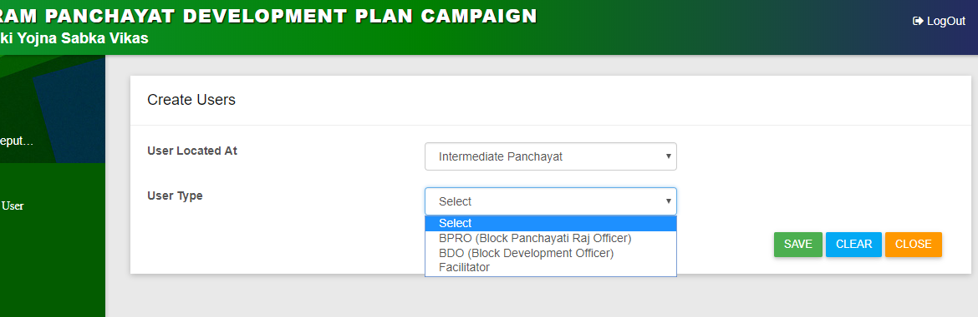

- GP level Users: Sarpanch and Panchayat Secretary User will be created at the GP level which will be created by the block level users.
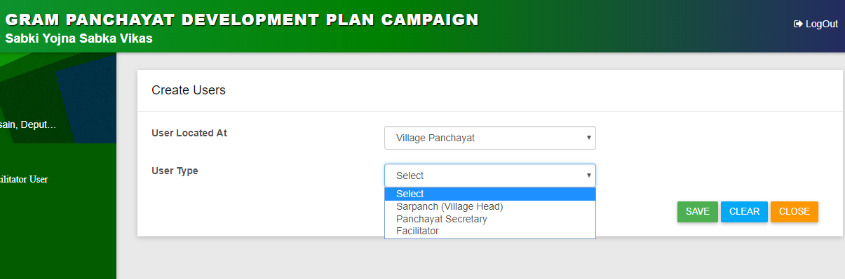

- Facilitators: Facilitator user for each gram panchayat will be appointed by the state. State may consider appropriate persons including officials for nominations. Roles of a facilitator would be
- Facilitate the special GS for GPDP on the designated day.
- Submit the report regarding the conduct of the Gram Sabha on the portal.
- Coordinating with frontline staff of participating ministries/departments.
- Supporting preparation of GPDP
- Upload GPDP on PlanPlus.

Creation of Facilitator user at District Level
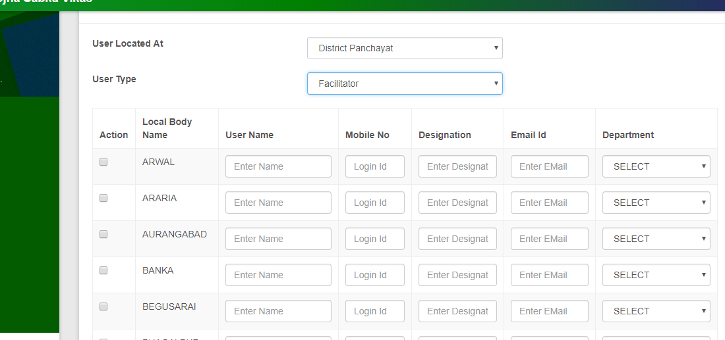
Creation of Facilitator user at Block Level
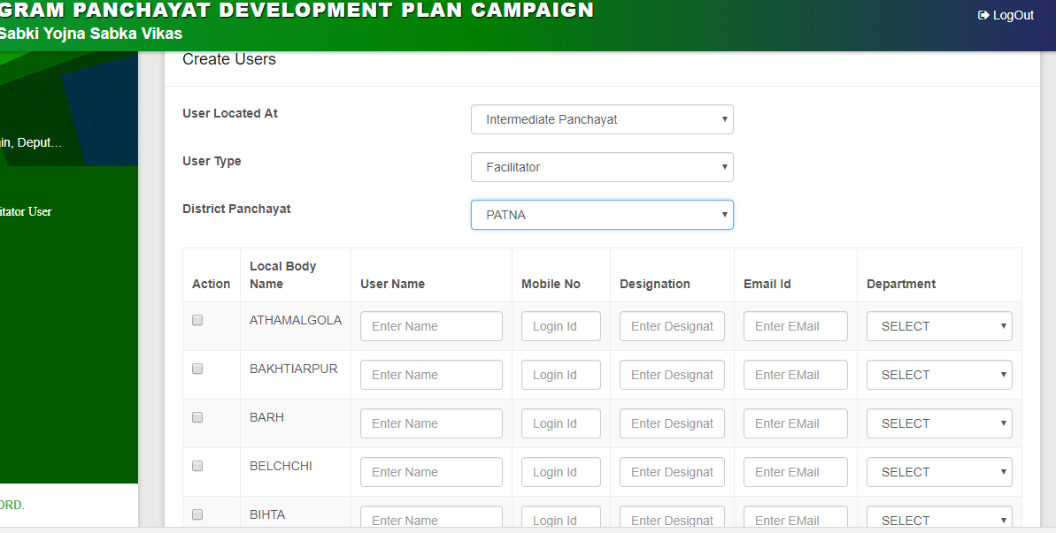

Creation of Facilitator user at Gram Panchayat Level
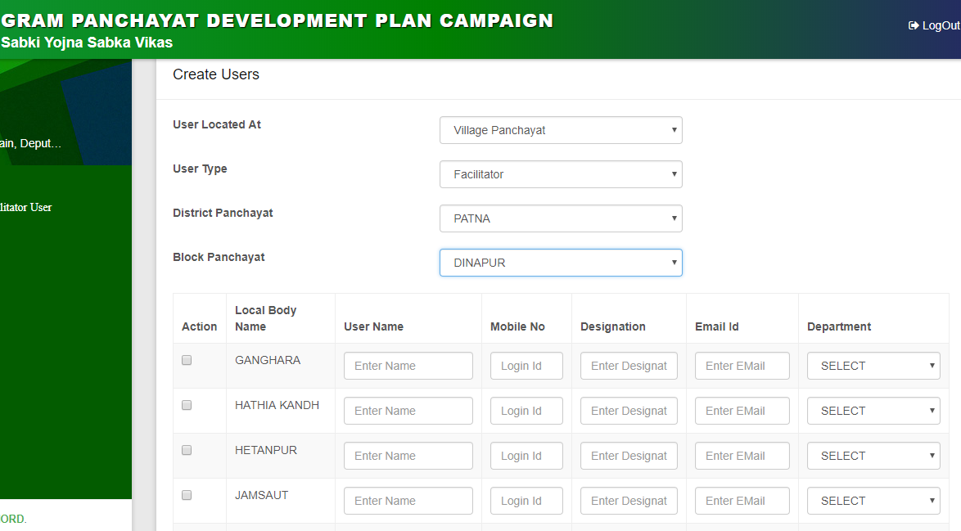

- Frontline workers: State level, District Level, Block level users are responsible for appointing and uploading the names of frontline workers to be deputed for Gram Sabha meetings on the designated days. The frontline workers will give a brief structured presentation regarding the activities of the department. Multiple frontline workers can be created at a single time for a department.
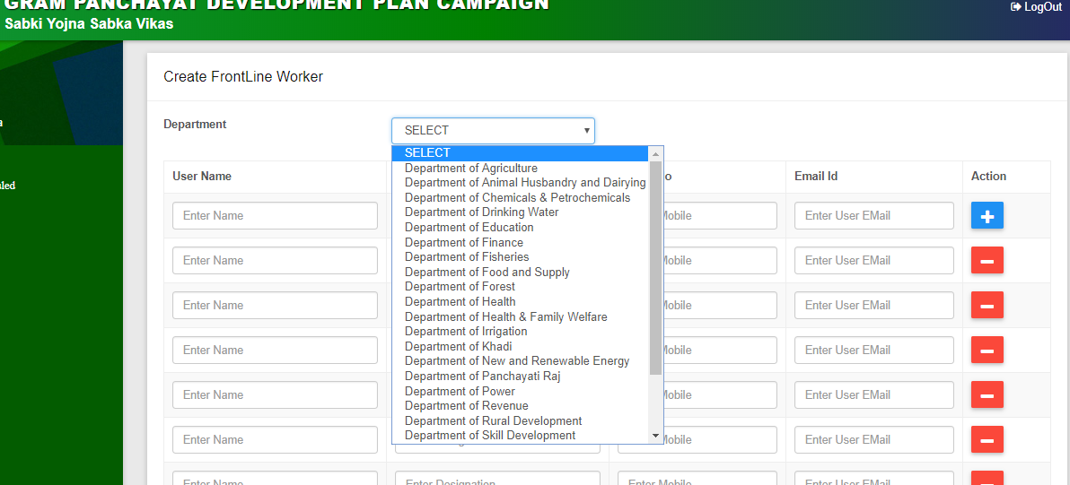

Following departments are being identified as frontline departments in GPDP campaign.
Department of Panchayati Raj
Department of Rural Development
Department of Agriculture
Department Health & Family Welfare
Department of Women & Child Development
Department of Power
Department of Chemicals & Petrochemicals
Department of Animal Husbandry and Dairying
Department of Revenue
Department of Drinking Water
Department of New and Renewable Energy
Department of Education
Department of Skill Development
Department of Social Justice
Department of Food and Supply
Department of Health
Department of Finance
Irrigation Department
Department of Fisheries
Department of Forest
Department of small scale industries
Department of Khadi
<State> Electricity Board
Rural Road Development Corporation/ PWD
Notification Module:
Notifications can be sent in the form of email and SMS to the entity based user. Notification can be sent from Central admin. Central Administrator will select the User Type. All the types of users are available in the drop down. Central admin needs to select the type of user and based on the selection of user type, users that all are available would be populated in the Select User section. Multiple users can be selected at once. Communication mode need to be selected for sending the notification.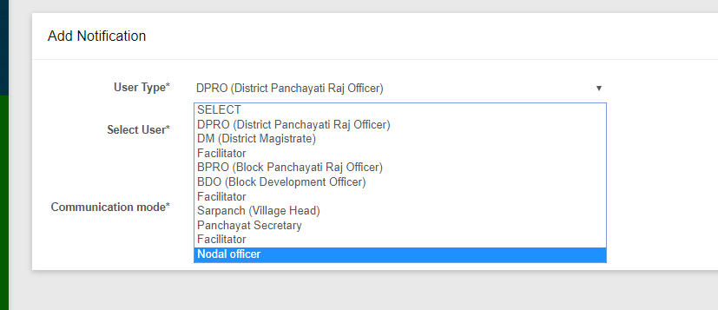

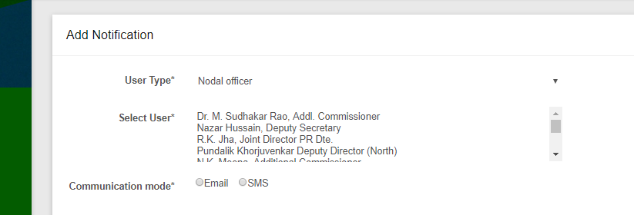
- Email based notification: An editor will be opened and central admin can enter the desired content and format the same as well. User can also add an attachment along with the email. As of now, any type of file can be attached.
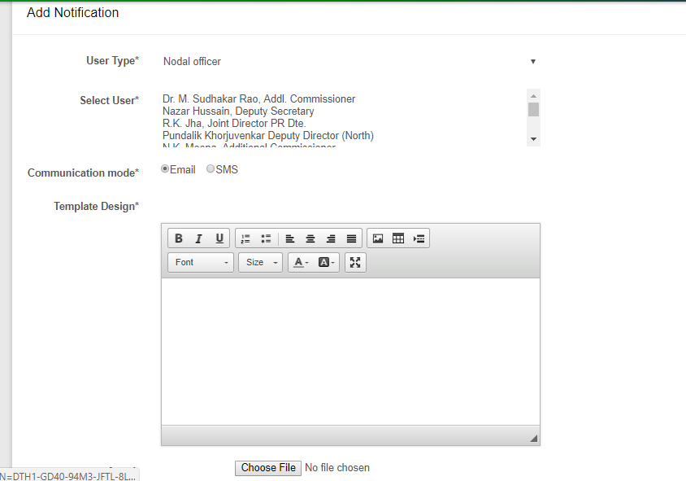
- SMS Based notification: A small text box will get opened and user can insert the message and can send it to the selected users.
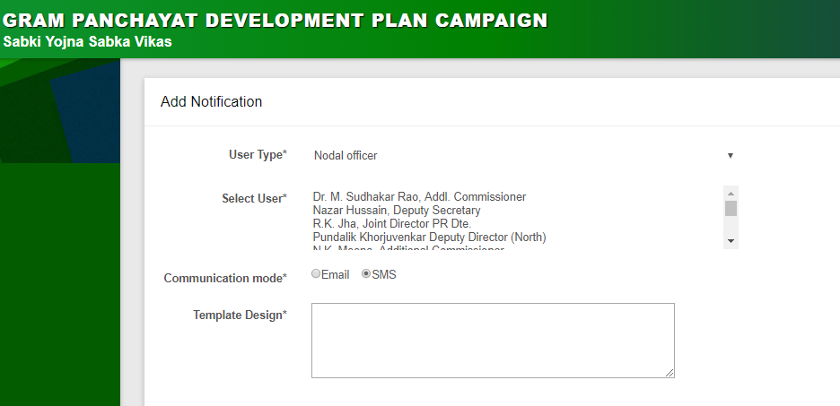

Special Gram Sabha Scheduled
Gram Sabha wise calendar for holding of Gram Sabha’s will be finalized at district/State level and the same will be uploaded on the portal. While scheduling the calendar of events of the Gram Sabha, States/Block/Facilitator may take care that within a block no two Gram Sabha meetings are scheduled on the same date so as to ensure presence of frontline workers of all line Departments. However, States/Block/Facilitator may schedule more than one Gram Sabha meetings in a block on the same date if they can ensure the presence of frontline workers from the line department in all Gram Sabha meetings.
For schedule of Gram Sabha, User needs to select the GP for which it needs to be scheduled. A date would be given for the gram Sabha
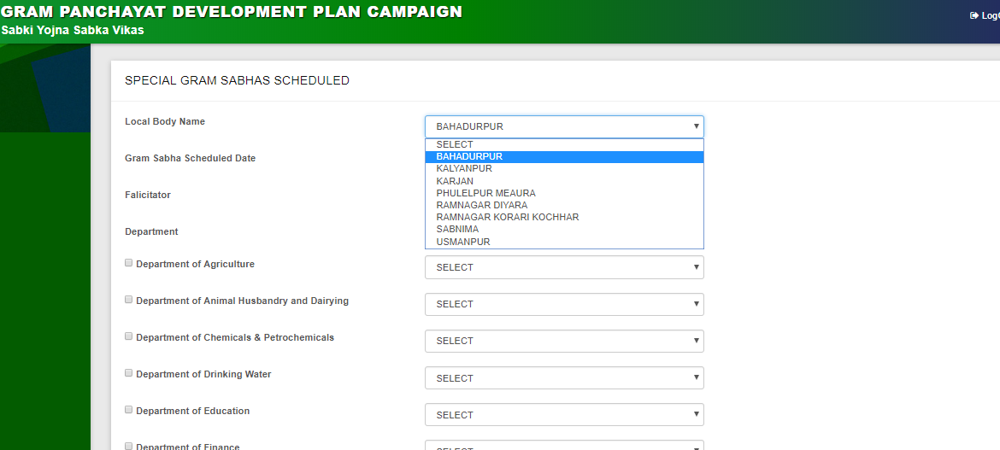
Screen shot for selecting the GP
Post selecting the GP, facilitator user needs to be selected for respective special gram Sabha. All the users would be populated in the drop down. A single user can be selected as a facilitator.
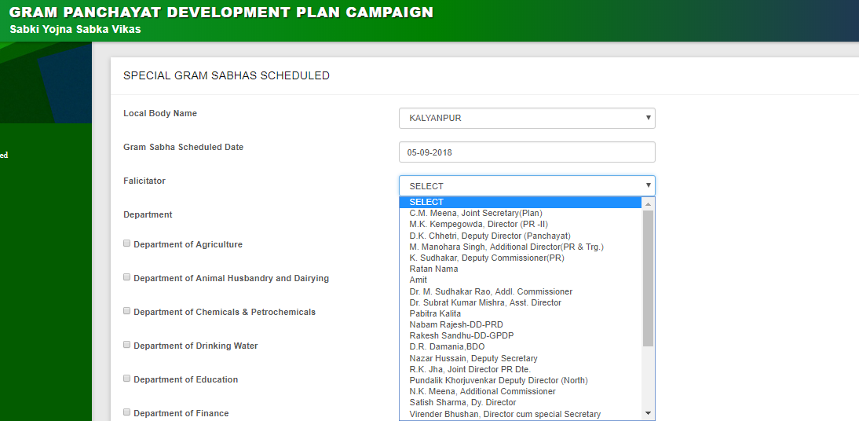
Screen shot of selecting the Facilitator
After filling the details of GP and facilitator, frontline departments and users’ needs to be selected for Gram Sabha. A check box is available against each frontline department for selecting the participating departments and then users will come into the drop down.

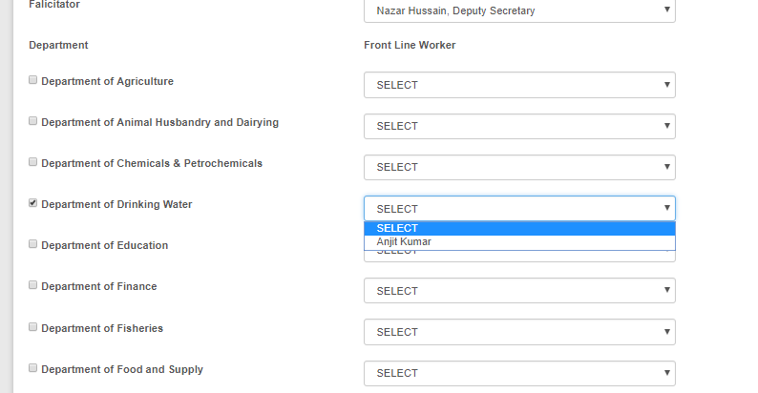
Screen shot of Selecting the Frontline departments and frontline users
User needs to click on the Save Button to save the details of Gram Sabha and it will be shown in the calendar.
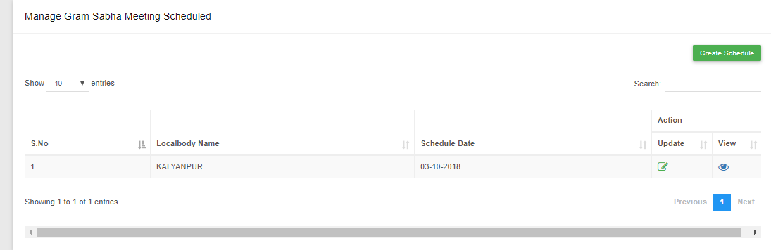

HOME PAGE:
After successfully saving the details of Gram Sabha Schedule, the scheduled Gram Sabha would be populated on the HOME screen of GPDP portal in the Calendar section. Any user (including Citizen) can click on the special gram Sabha in calendar and can see the participating departments of respective gram Sabha. This functionality is under development.
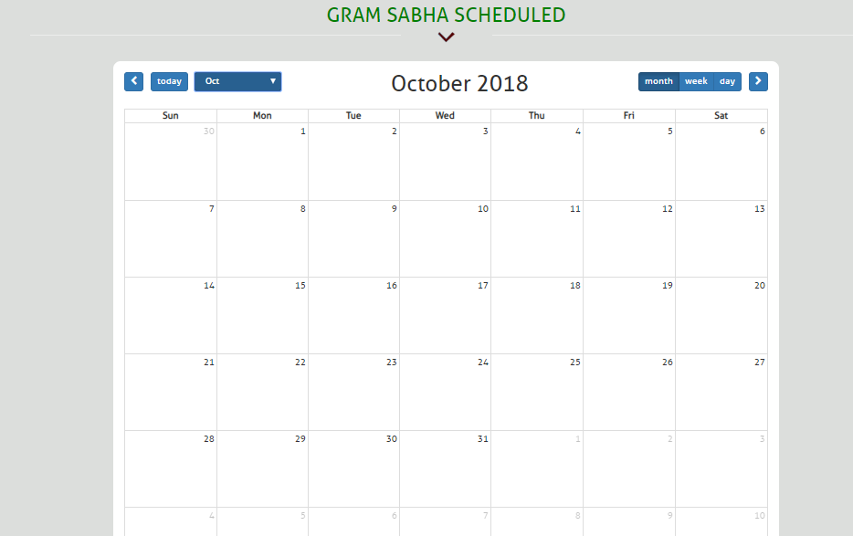
Gram Sabha Schedule Calendar

Our Achievement:
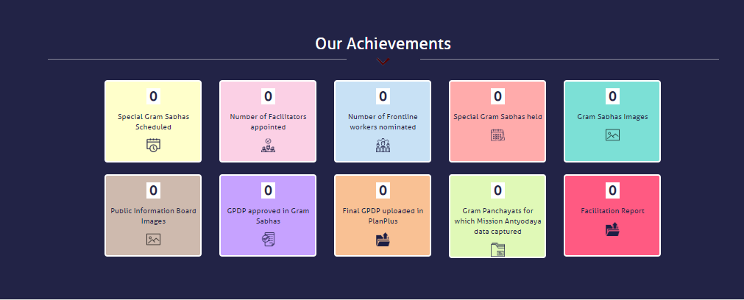
Our Achievement section on home page
Special Gram Sabha Scheduled: Counter will be increased by 1 in Our Achievement section after successfully schedule of each Gram Sabha. This functionality is under development.
Number of Facilitators appointed: Counter number will be increased by 1 post appointing facilitators for each Gram Sabha.
Number of frontline workers appointed: Counter number will be increased by 1 post appointing frontline worker for each Gram Sabha.

Special Gram Sabha Held: Counter will be increased in this section after the Special Gram Sabha meeting would be held.
Public Information Board Images: Display of Public Information Board in every Gram Panchayat and uploading of geo-tagged photographs of it on the web portal.
Facilitator Report: Counter will be increased by 1 post completion of Special Gram Sabha meeting; facilitator will fill a feedback form which is having details like, how many people were present in the Special Gram Sabha. Out of those, how many SC’s/ST’s/Women were the participants. Details like which all frontline departments participated and showed the presentation and can also upload the geo tagged photographs and videos related to Special Gram Sabha and Public Information board. All these information will be captured as part of facilitator’s report which can be seen by the users (Including Citizen)

GPDP android mobile app:
Splash Screen:
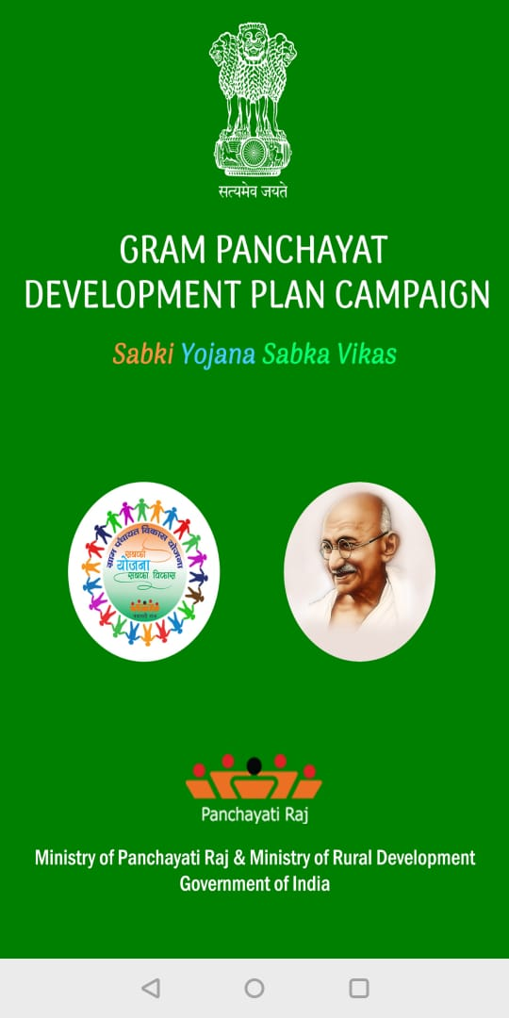
Officer Login Screen:
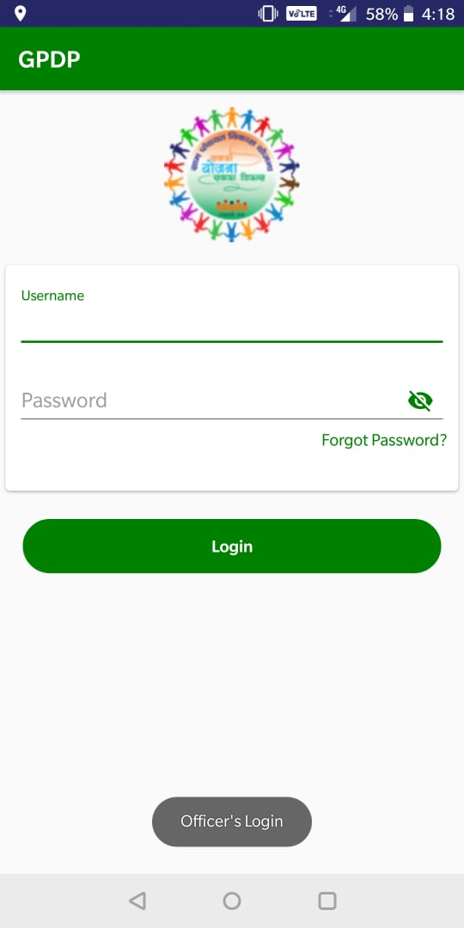

Home Screen: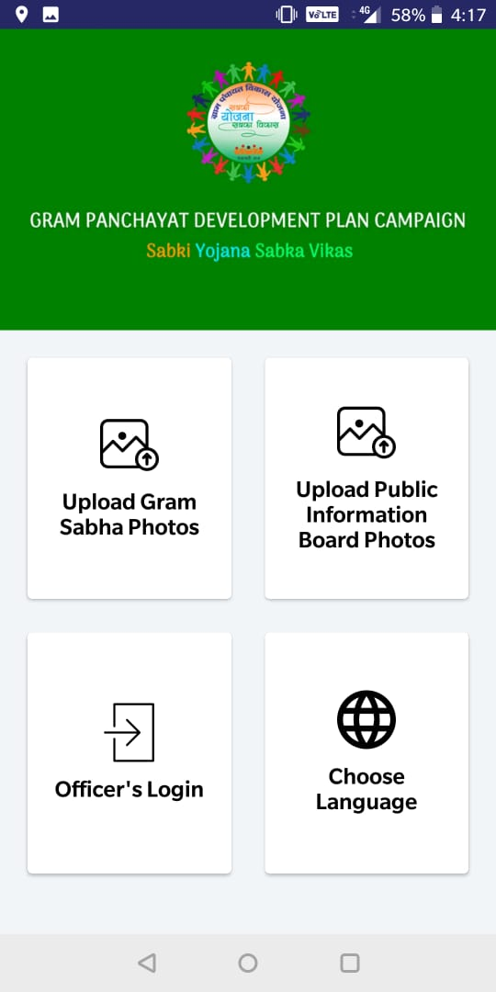

Location Screen:
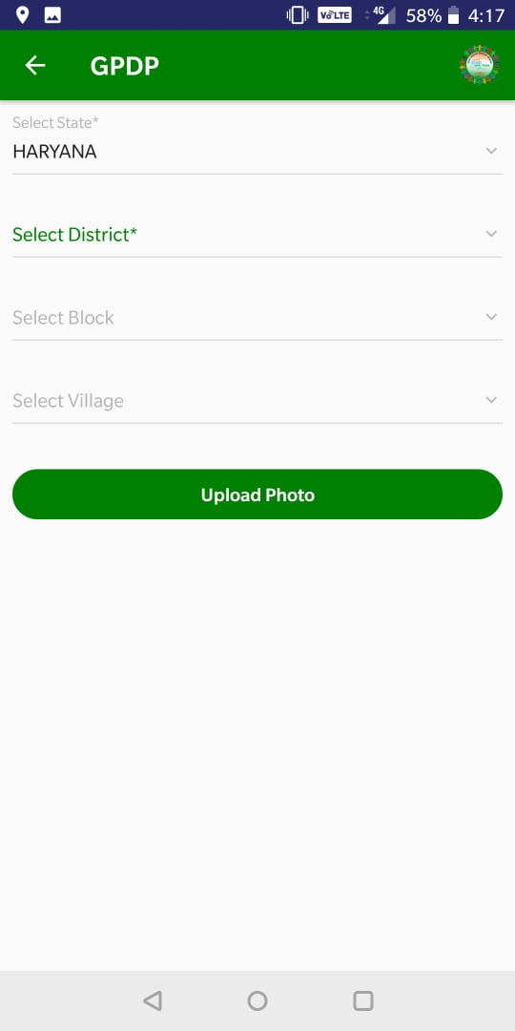

Upload Screen:
