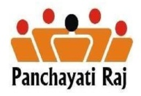

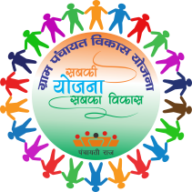
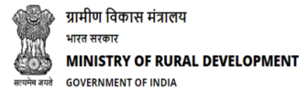
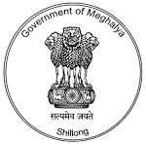

KA SHNONG JONG NGA KA PLAN JONG NGI
MY VILLAGE MY PLAN
VDP-GPDP
Programme Schedule jong ka Block level Environment Generation Campaign VDP –GPDP
VDP-GPDP
Por | Ka Mat Ban Kren |  | Nongkren
9.30 am-10.00 am | Registration |  | Gram Sevika
10.00am-10.20am | Ka Jingkren lyngkot shapahng ka programme da i BDO |  | BDO
10.20am-11.00am | Shaphang ka VDP-GPDP |  | State Resource Group(SRG) Team
11.00am-11.15 am | Por Dih sha
11.15am-1.00pm | Ka jingkren na ki Line Department (5 minute)  - Social Welfare Department  - Family welfare and Health Department  - Education Department  - Agriculture and Horticulture Department  - AH&Vety Department  - P.H.E.D Department  - PWD(PMGSY) Department t  - Commerce and Industries Department t  - Forest & Environment Department  - Fishery Department  - Meghalaya Electricity Power Corporation Limited. | - Irrigation and Water Resource Department.  - Soil Conservation Department  - Sports and Art & Culture department  - Tourism Department  - Sericulture & Weaving Department  - BADO  - Co-operation Department  - Employment and Craftsmen Department.  - Housing Department  - Food ,Civil Supplies and Consumer Affairs  - Revenue and Disaster management Department  - MSRLS-NRLM  24.SRES-MGNREGS
1.00pm-1.10pm | Ki mat ba donkam na ka bynta ka VEC/Village Council Chairman bad Secretary |  | BDO/SRG Team
1.10pm-1.45pm | Por Bamja
1.45pm-2.15pm | Kaba pynkhreh ia ka Calendar na ka bynta ka VDP-GPDP plan ha shnong |  | SRG Team/Support team from Block officials
2.15pm-2.30pm | Ka Jingkren/Presentation jong ka Block Resource Envelope |  | SRG Team
2.30-pm-3.00pm | 1.Ka jingphylliew jingmut halor ka roi ka par/ development ha Block 5 snem mynshwa (2012-2017)  2.Ka jingphylliew jingmut halor ka roi ka par/ development ha Block mynta u snem(2017-18)  3. Ka jingphylliew jingmut halor ka roi ka par/ development ha Block 5 snem hadien (2018-2023) |  | SRG Team(Minutes of the discussion shall be recorded by the SRG team)

Sd/-
Block Development Officer

